Swallow’s  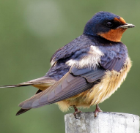  Newsletter | Viscount Beaumont’s CofE Primary School  Summer Term  ‘All can participate; all can enjoy; all can achieve because our life together is shaped by the Fruit of the Spirit.’ Galatians 5:22 |  |  |  |  |  |     v
We hope that you have all had a well-deserved Easter break. There is lots going on throughout the Summer term, so please keep your eye on the school newsletters and Dojo.
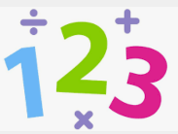  Maths  Time, decimals and money. After half term we will be looking at shape, position and direction and statistics. |  | 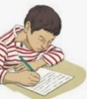  Writing  This term we will be writing to inform report and after half term we will be writing to persuade Speech. |  | 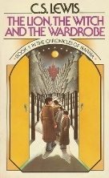  Reading  This term we will be reading the Lion the witch and the Wardrobe. |  |   RE  We will be learning about for  Christians, when Jesus left, what was the impact of Pentecost? After half term we will be looking at why people mark significant life events.
PE    We will be playing Netball and looking at health and fitness. After half term we will be playing team games and ball games. |  |   History  We will be learning all about Ancient Greeks. |  |   Computing  We will be learning how to program a sequence. After half term we will be learning how to programme repetition in shape. |  |   Science  We will be learning all about Light and how it travels.
  Music  We will be continuing to practice our Rise Voices songs and them moving on to the topic Stop! |  |   PSHCE  This term we are learning about valuing difference and respect and challenges. After half term we will be looking at how we grow and change. |  |   French  This term we will be learning about how to present ourselves. After half term we will be learning how to tell the story of Goldilocks |  |   Geography  We will be learning all about Mountains
Diary dates:
Forest School Wednesday 30th April then every Friday starting on the 9th May
Rise voices (Year 4) Wednesday 7th May
Sports event (Year 3) Tuesday 20th May
Swimming Wednesday 21st May (every Wednesday)
Rock star day Friday 23rd May
Meanwhile…At home, please remember to…
  Read with your child at least four times a week! Encourage them to read different genres and a range of fictions and non-fiction texts |  |  |   Prompt them to practice their times at least three a week table using TTRS. |  | 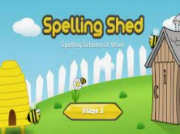  Practice your child’s spellings with them three times a week – Tests will be on Fridays.
Please ensure the children have the appropriate P.E kit in school at all times, as our P.E day may change.

