Swallow’s  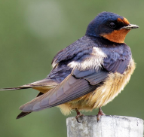  Newsletter | Viscount Beaumont’s CofE Primary School  Autumn Term  ‘All can participate; all can enjoy; all can achieve because our life together is shaped by the Fruit of the Spirit.’ Galatians 5:22 |  |  |  |  |  |     v
We hope that you have all had a well-deserved summer holiday. There is lots going on throughout the Autumn term, so please keep your eye on the school newsletters and Dojo.
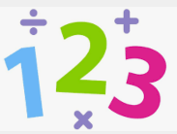  Maths we will be learning about fractions and mass & capacity. |  | 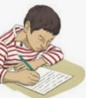  Writing  we are writing to entertain, learning how to identify similes and writing imagery and sound. |  | Reading  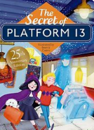  we are looking at The Secrets of Platform 13 by Eva Ibbotson |  |   RE  Judaism  We will be looking at how festivals and family life show what matters to Jewish people?
  PE  We are expressing ourselves the dance and learning how to move our bodies. Practising Quick sticks skills |  |   Geography  we are investigating weather and climate, including the factors that can cause an impact on both. |  |   Computing  We will create media, including audio production |  |   Science  We are investigating States of matter, looking at solids, liquids and gases, including the factors that can cause change.
  Art  we are exploring artitecture |  |   PSHCE  We are looking at being our best, healthy eating and being our fantastic selves! |  |   French  We will be learning how to order ice cream |  |   Music  we will be practising  the song for our  Rise Voices  performance
Please make sure that your child brings both their indoor and outdoor PE kit into school every Monday morning and takes it home to be washed on a Friday afternoon. PE sessions could be on any day.
Meanwhile…At home, please remember to…
  Read at least four times a week with your child! Encourage them to read different genres and a range of fictions and non-fiction texts |  |  |   Prompt them to practice their times table at least three times a week using TTRS. |  | 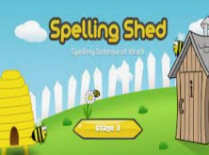  Practice your child’s spellings with them – Tests will be on Fridays.
Diary dates!
Specsavers visit – 24th Feb
Parents evening – 4th – 5th March
World book day – 6th March
Quick sticks – 11th March
Science fair – 13th March
Easter performance – 3rd - April

